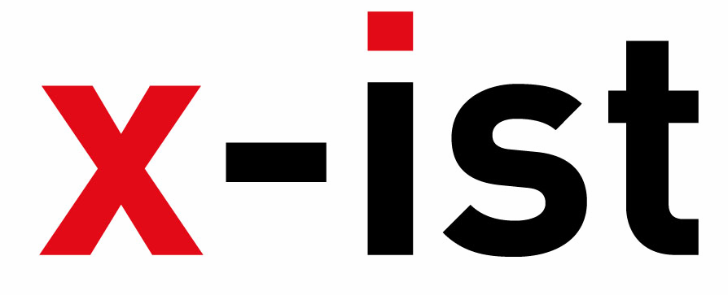 | Abdi İpekçi Caddesi Kaşıkçıoğlu Apt. No:42 D:2 34365 Nişantaşı İstanbul  www.artxist.com  info@artxist.com  T. +90 212 291 77 84 F. +90 212 343 69 35 | PRESS RELEASE

INTERNAL AFFAIRS
In his first solo show “Internal Affairs” between 18 February – 13 March 2010, Cem Dinlenmiş breaks the traditional boundaries of art to present his ideas on a three dimensional platform.

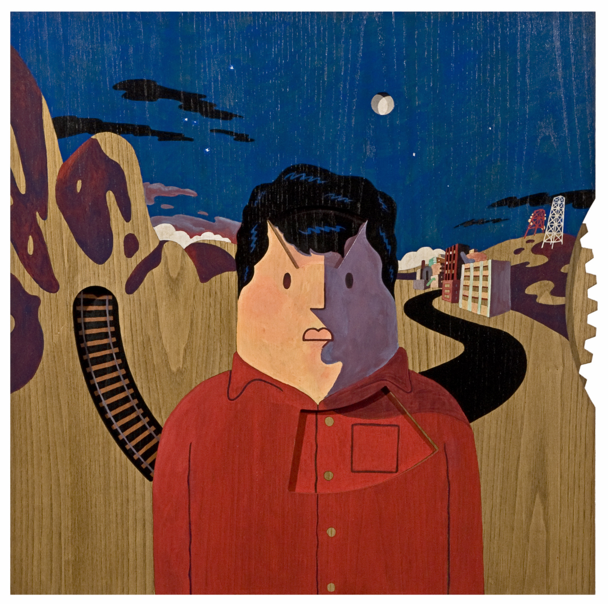
Travel , marker on wood, 70x70cm, 2009
Even under the day to day attempts to do something new or different in contemporary world, Cem Dinlenmiş’s work truly is unconventional and stands alone. Since 2006, he has actively continued his column “Her Şey Olur” (Anything Goes) in one of Turkey’s most respected critical humor magazines, Penguen. His tone is contrary, absurd and at times ironic, and his line is clear, bold, and unapologetic. His unique style sets the stage for these new exciting works which are hell-bent on breaking the frame.
The collection of works in his show “Internal Affairs” takes us on a many-faceted journey. The landscape changes constantly from an external influence to an internal dilemma. The artist also draws in the normally passive viewer to interact with the works. In such pieces as “Travel” and “States of Mind”, we truly see the playful side of the artist. His cartoonist/illustrator alter-ego brings a refreshing change from conventional structure and form truly reflecting their place of birth.
In short, while Cem Dinlenmiş presents us with endless details of social and daily life which he’s involved in, he also reminds us of different perspectives we can take on things and concepts we assume to be ordinary.

CEM DİNLENMİŞ Istanbul, 1985

In 2008, Dinlenmiş took place in the group show Intersection III in x-ist. The other group exhibitions and fairs he has participated are “Connect the Dots”, (Hafriyat, Karakoy, Istanbul, 2008), “Young Istanbul” (Färgfabriken, Stockholm, 2008) and Contemporary Istanbul ‘09. In 2009, Dinlenmiş was one of the six artists who contributed in the presentation of the illustrated novel “Istanbul Zombie 2066”, which was published in Barcelona, Spain in English and Turkish. The artist continues his education at Marmara University, Faculty of Fine Arts, Graphics Department and draws for Penguen Magazine.

